Tianyi Sun Assignment 1
URL: https://macneill.scss.tcd.ie/~tisun/portfolio/
all relative html/css documents have all been validated.
Site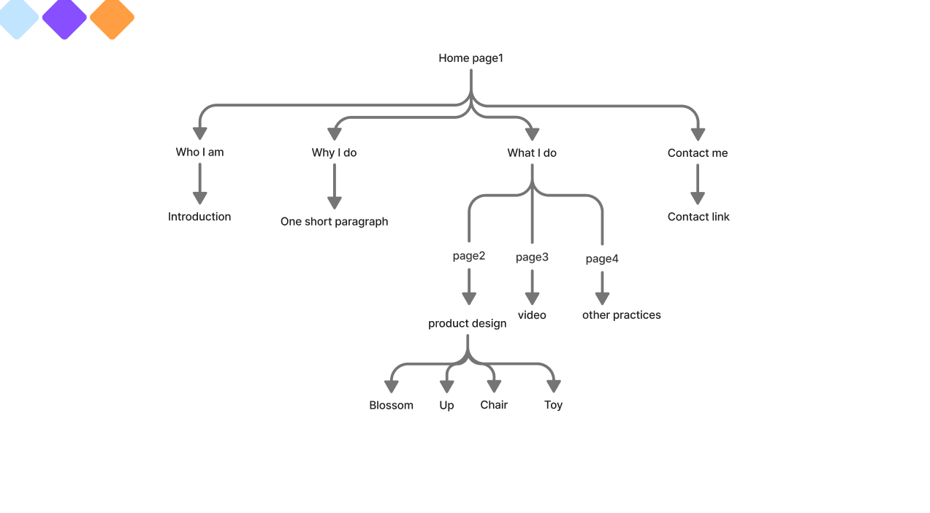Site Overview
This website run as my portfolio page, showing 3 different aspects of the works, I have done. It includes three main sections: Product design, videos and other practices. Each section represents a different area of my design practice. The header aims to guide readers to different pages and parts of the website in a simple flow. There is also a logo of my name, once reader click it, it navigates them back to the homepage, and all the pages are able to switch between each other.

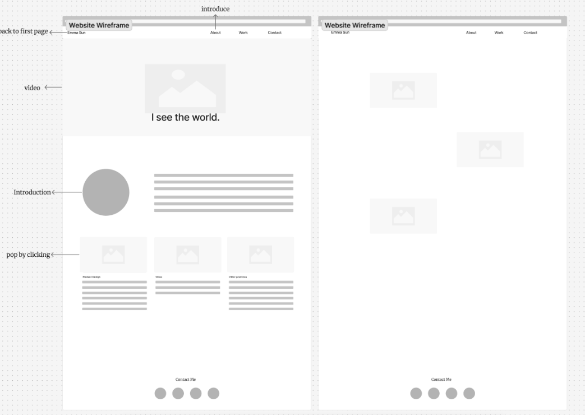
Wireframe

Design Outline
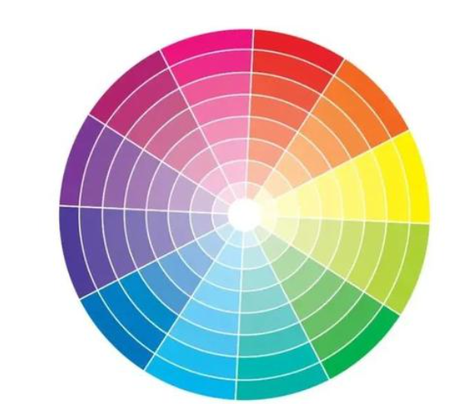
I chose contrasting color, using a light blue and orange color scheme to make the layout clean and consistent. Two fonts are applied for hierarchy and readability. Small hover effects and a fixed navigation bar make the site easy to use.
In the Product Design section, I used a grid layout to organize the large exhibition boards, arranging them alternately from left to right for better visual balance. The Video section presents the works directly with embedded clips and links to more videos. The Other Practices part uses still images to display smaller projects. All clickable elements include a hover zoom effect to add a simple animation and guide interaction.

